Chapter 1
Introduction
1.1 Background of the Study
Examination result processing is one of the most essential operations in any educational or examination authority. Traditionally, student results were prepared manually by collecting score sheets, calculating totals, preparing merit lists, printing scorecards, and distributing them physically. This manual approach increases the chances of errors, delays in publishing results, and difficulty in maintaining record accuracy.
With the rapid digital transformation happening worldwide, examination bodies are shifting toward automated result management systems. The Online result portal is an attempt to modernize the traditional process using the principles of Database Management Systems (DBMS). The system allows students to log in, check their results instantly, view their scorecards, download digital copies, and verify rank lists and cutoffs all through a centralized platform.
1.2 Role of DBMS in Modern Result Systems
A DBMS plays a crucial role in securely storing and efficiently processing examination-related data. The following DBMS features are essential for the success of such a project:
1.2.1 Data Integrity
DBMS enforces rules that prevent invalid or inconsistent data from entering the system. For example, every roll number must be unique, and every student must belong to a valid category (GEN, OBC, EWS, SC, ST).
1.2.2 Data Consistency
When multiple queries are executed for example, rank generation and scorecard preparation the DBMS ensures all derived values (percentile, ranks, status) remain consistent across screens.
1.2.3 Security & Authentication
Only authorized students can log in using their Roll Number and Date of Birth. Unauthorized access is prevented.
1.2.4 Data Accessibility
Students can access their results anytime without depending on physical result sheets.
1.2.5 Transaction Management
DBMS ensures ACID (Atomicity, Consistency, Isolation, Durability) properties, essential for reliable exam result storage.
1.3 Need for an Online Result System
An online result platform is required for the following reasons:
1.3.1 Instant Availability
Once results are processed, students should be able to view them immediately without waiting for physical distribution.
1.3.2 Error-Free Data Handling
Manual result systems often face issues such as incorrect marks, misplaced records, and calculation errors.
1.3.3 Centralized Storage
All result data is stored in a centralized database, making updates easy and reliable.
1.3.4 Student Convenience
Students can check results from home using a mobile or computer.
1.3.5 Transparency
The system ensures fairness by showing percentile, AIR, category rank, and cutoff values clearly.
1.4 Objectives of the Project
The main objectives of the Online Student Result Portal are:
1.4.1 Automation of Result Processing
To reduce workload for exam administrators by automating steps like score calculation, rank generation, and scorecard preparation.
1.4.2 Centralized Data Management
To store student profiles, exam details, marks, ranks, and cutoffs in a well-structured database.
1.4.3 Student Self-Service Access
Students should be able to log in independently without contacting the authority.
1.4.4 Reduction in Human Errors
Automation ensures mathematical accuracy and eliminates manual mistakes.
1.4.5 Faster Decision-Making
Cutoff, rank list, and result summary help authorities make admission and counseling decisions faster.
1.5 Scope of the Project
The project includes:
1.5.1 User Login System
Using roll number and date of birth as authentication credentials.
1.5.2 Dashboard
A centralized control panel containing shortcuts for all major actions.
1.5.3 Result Viewing Module
Shows percentile, marks, AIR, category rank, and overall performance.
1.5.4 Scorecard Download
Allows students to download/print scorecards from the system.
1.5.5 Rank List Generation
Displays student merit list sorted by percentile.
1.5.6 Cutoff Module
Shows category-wise cutoff values for admission eligibility.
1.5.7 Announcement & Date Display
Important notifications and exam schedule are updated dynamically.
1.5.8 FAQ Support
Helps students find answers to commonly asked questions.
1.6 Importance of the Project for Students
- Students receive fast access to accurate results.
- All records remain safely stored in digital form.
- No need to visit institutions physically for results.
- Helps in admission and counseling preparation.
1.6.1 Importance of the Project for Exam Authorities
  - Reduces manual labor and paperwork.
  - Prevents data loss and ensures record security.
  - Easy to update announcements, dates, and revaluation information.
  - Scalable for millions of students.
1.6.2 Advantages of the Project
- Real-time results
- Downloadable PDF scorecards
- Secure authentication
- Reduced errors
- Better student experience
- Fast ranking and sorting from database
- Category-wise cutoffs automatically displayed
1.6.3 Limitations
- Requires stable internet connection.
- Wrong DOB/roll number results in login failure.
- Admin panel and revaluation module not implemented in UI provided.
1.6.4 Applications of the System
- University and college entrance exams
- Government examinations
- Scholarship tests
- Semester exam result portals
- Private institution testing portals

Chapter 2
System Design
The online result portal is designed using DBMS architecture and modular UI design principles. The system ensures smooth navigation, accurate data retrieval, and user-friendly interaction. This chapter explains the complete workflow, architecture, diagrams, and detailed descriptions of all screens.
2.1 System Overview
The system follows a three-tier architecture:
1. Presentation Layer (Frontend)
- Displays login page, dashboard, result screen, scorecard, merit list, cutoff details, FAQs, etc.
- Accepts user input (Roll No & DOB).
- Communicates with backend for result retrieval.
2. Application Layer (Backend)
- Validates login credentials.
- Processes result queries.
- Generates rank list.
- Retrieves cutoff values.
- Formats scorecards dynamically.
3. Database Layer
- Stores all student records, exam data, results, cutoffs, announcements.
- Executes SQL queries.
- Maintains data integrity and relationships.
2.2 Student Login Screen
Purpose:
Allows student authentication using Roll Number and Date of Birth.
Backend Logic:
SELECT * FROM Student
WHERE RollNo = ? AND DOB = ?;
Features:
- Input validation
- Error message if credentials do not match
- Redirects to Dashboard after success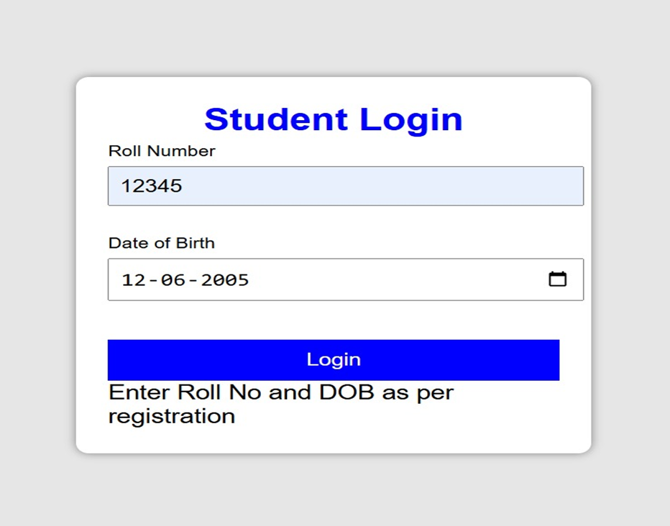
Fig 2.1 Login Screen
  - Dashboard / Home Screen
Dashboard provides quick access to:
  - Result
  - Scorecard
  - Rank List
  - Cutoff
  - Important Dates
  - Announcements
  - FAQs
Importance: Central navigation panel for all modules.
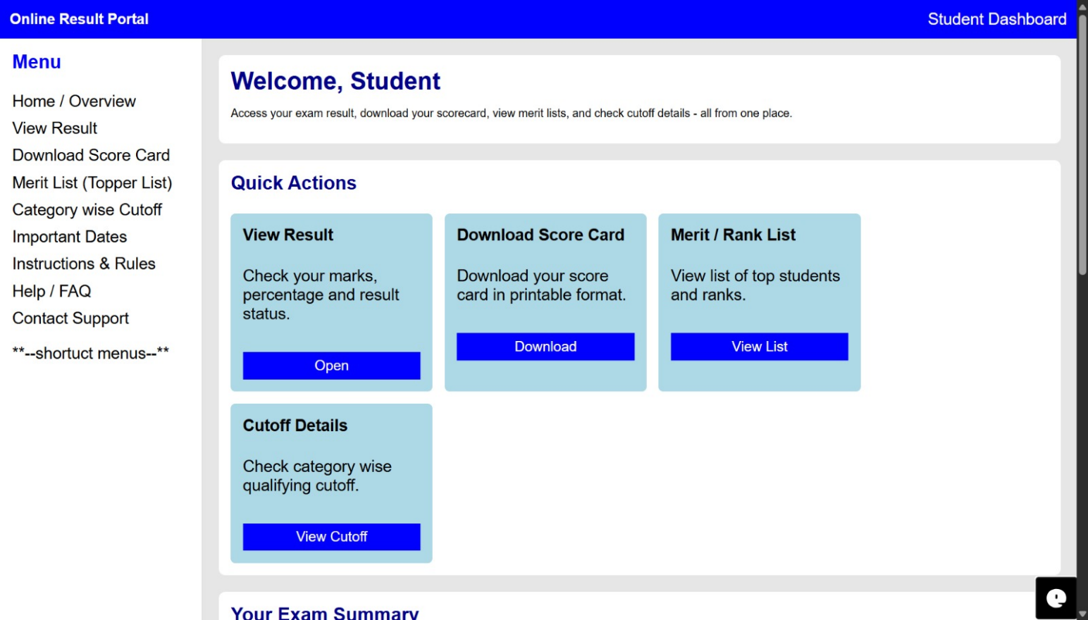
Fig 2.2 Dashboard
2.4 Result Summary Screen
Shows:
  - Percentile
  - All India Rank
  - Category Rank
  - Total Marks
  - Result Status
Description:
This screen gives the student a rapid overview of performance.
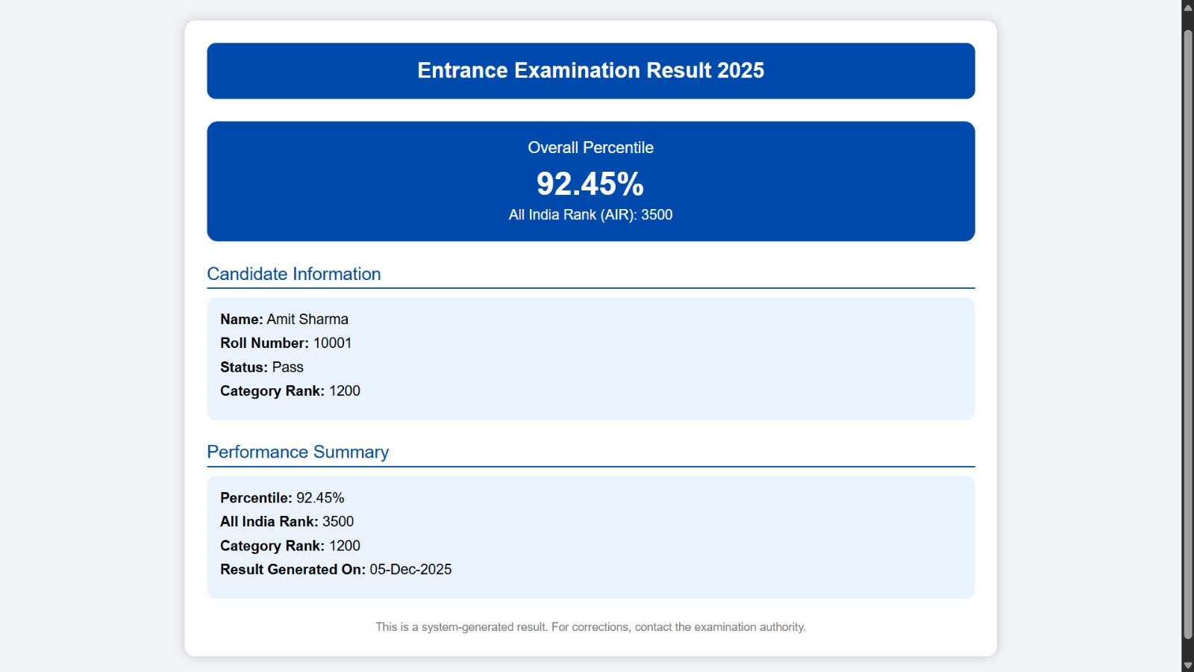
Fig 2.3 Result Summary Screen
2.5 Scorecard Screen
Contains:
- Candidate details
- Performance metrics
- Score breakdown table
- Result generation date
The scorecard is dynamically generated from the database.
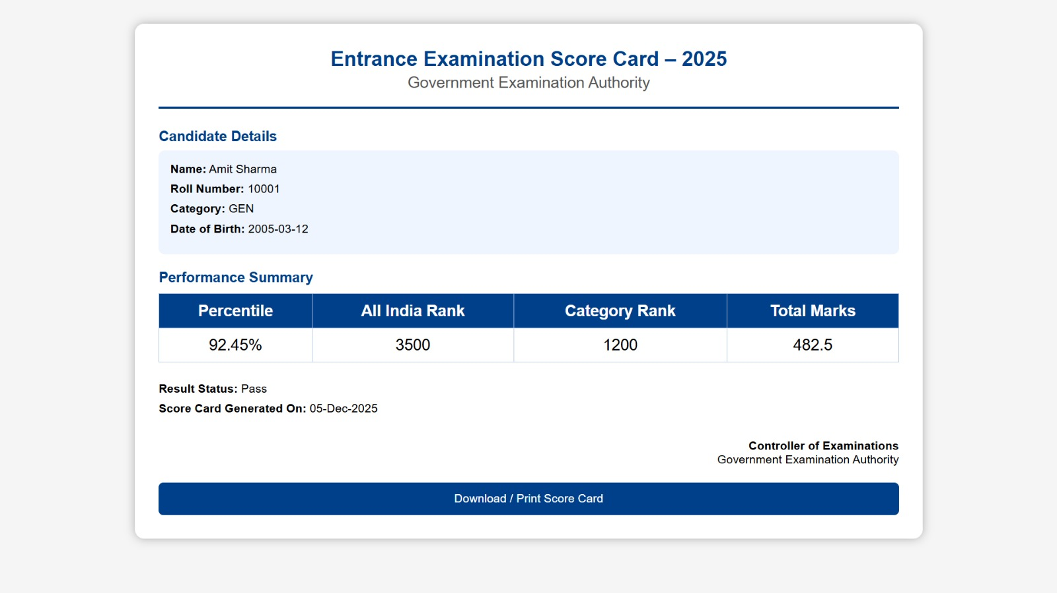
Fig 2.4 Scorecard Screen
2.6 Merit / Rank List Screen
Ranks sorted by:
- Percentile
- Total Marks
Query to fetch rank list:
SELECT * FROM Result ORDER BY Percentile DESC;
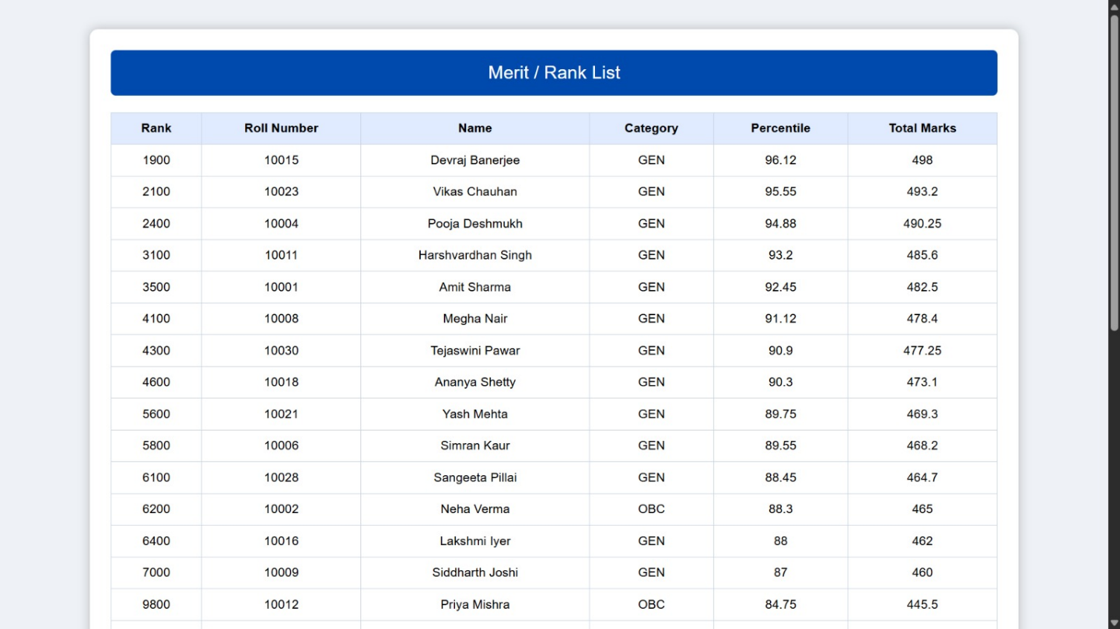
Fig 2.5 Merit / Rank List Screen
2.7 Category-wise Cutoff Screen
Cutoff includes:
- GEN
- EWS
Each cutoff value is stored in the Cutoff table.
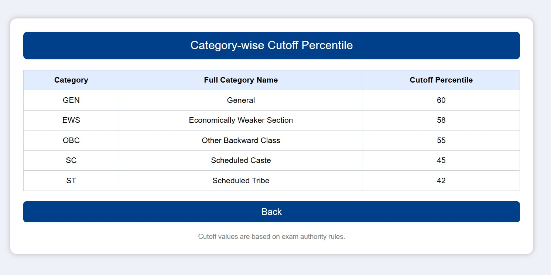
Fig 2.6 Category-wise Cutoff Screen
2.8 Exam Summary & Announcements Screen
Displays:
- Student exam details
- Updated notifications
- Important exam dates
- Useful links
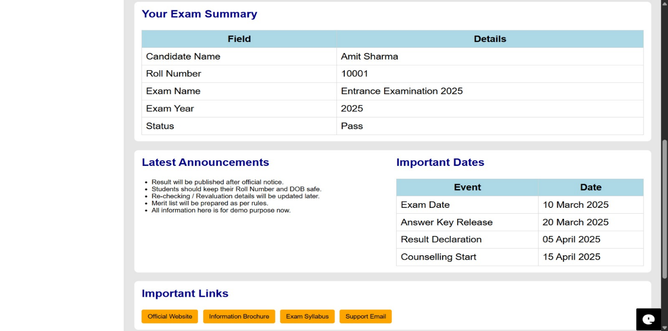
Fig 2.7 Exam Summary
2.11 Design Principles Followed
User-Centered Design
Simple layout for easy navigation.
Database Normalization
Data redundancy minimized to maintain integrity.
Modular Design
Each feature is built as an independent module.
Security & Authentication
Only valid students can access results.

Chapter 3
Testing and Results
3.1 Testing Strategy
Testing is an essential phase in software development to ensure that the system performs correctly, meets functional requirements, and delivers expected results without errors. For the Argo Culture, a combination of Unit Testing, Functional Testing, and Manual Interface Testing was used. Each module such as registration, login, product posting, and ordering was tested individually and then integrated for system-level testing. The main objective of the testing strategy was to validate system accuracy, improve quality, and identify defects before deployment.
3.2 Unit Testing
Unit Testing was conducted to verify the correctness of individual functions and backend operations. Each component was tested separately to ensure expected outputs. For example, the login validation method was tested with valid and invalid credentials, while database-related functions were tested using dummy sample records. CRUD operations (Create, Read, Update, Delete) for product management were tested to check data response and execution timing. This helped detect errors early during development and ensured the reliability of each component before system integration.
3.3 Functional Testing
Functional testing was used to validate the system’s features and confirm that they work according to user requirements. All primary functions such as registration, login, product upload, product display, order placement, and logout were tested. The interface flow was checked to ensure smooth navigation and response. Edge condition testing like empty form submissions, incorrect price values, and incorrect email format validation was also performed to ensure input restrictions.
3.4 Login Functionality
Testing Login functionality was tested under parameter-based validation to ensure secure system access. Both farmer and customer login roles were tested separately. Invalid and empty inputs were checked for error messages.
3.5 Results
After conducting various tests, it was observed that all system modules performed successfully without major defects. The system responded accurately to real-time inputs, performed fast database processing, and handled user role-based login securely. The results confirm that the system meets its expected functionality and is ready for user deployment and real-time usage

Conclusion
The online result portal successfully demonstrates how database technologies can be applied to simplify and automate examination processes. Through the use of a structured DBMS, the system ensures secure data storage, fast retrieval, error-free calculations, and efficient result publishing. It provides students with a seamless experience by allowing them to log in, view their results, download scorecards, check category-wise cutoffs, and access important announcements and dates from a centralized platform. The database design including normalized tables, ER models, relational constraints, and SQL-based operations ensures data integrity, reduces redundancy, and supports reliable multitier architecture. The implementation of modules such as Login, Dashboard, Result Display, Merit List, Cutoff Information, and FAQ shows how different database components work together to form a complete information system.
This project highlights the importance of DBMS in modern educational institutions, where automation and digital accessibility are essential. The system is scalable, secure, and capable of handling large volumes of data efficiently. It also provides transparency and ease of use, making it beneficial for both students and examination authorities.
In conclusion, the project meets all its objectives and offers a strong foundation for future enhancements such as an admin portal, revaluation module, counselling system, automated notifications, and mobile app integration. It proves that a well-designed DBMS can significantly improve result management while ensuring accuracy, reliability, and user satisfaction.

REFERENCES
- Silberschatz, A., Korth, H. F., & Sudarshan, S. Database System Concepts, 6th ed. McGraw-Hill, New York, 2011. ISBN: 9780071325224
- Pressman, R. S. Software Engineering: A Practitioner’s Approach, 8th ed. McGraw-Hill, 2014. ISBN: 9780078022126
- Sommerville, Ian. Software Engineering, 10th ed. Pearson Education, 2016.
ISBN: 9780133943030
- Balagurusamy, E. Programming with Java: A Primer, 5th ed. McGraw-Hill Education, New Delhi, 2014. ISBN: 9781259063724
- Elmasri, R., & Navathe, S. B. Fundamentals of Database Systems, 7th ed.Pearson Education, 2015. ISBN: 9780133970777

